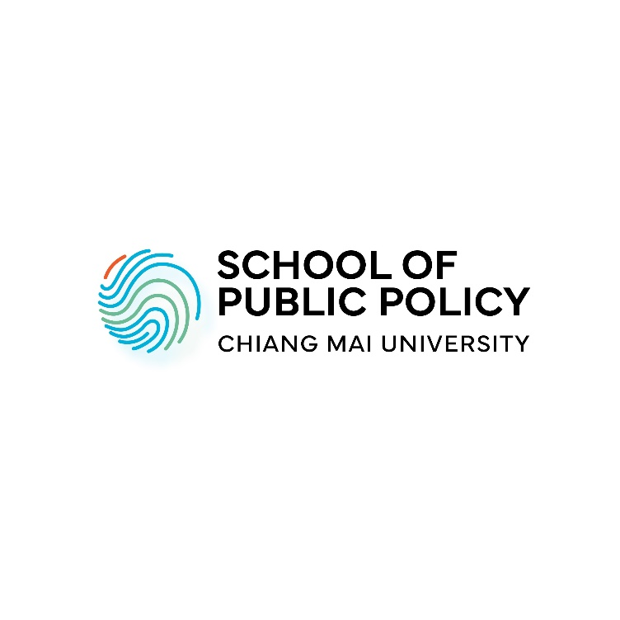

Master of Arts in Public Policy Program
Application Checklist
Chiang Mai University School of Public Policy

Name/ Last Name:
Gender:
Nationality:
Date of birth:
*** Please assemble all required application documents in the following order into one PDF file, and email to spp@cmu.ac.th, also upload your application from to CMU Admission portal at website: Application for Graduate study, Chiang Mai University (cmu.ac.th). The PDF file should be named as such:
"CMU-SPP_MA-Name Last name"…
☐ Application checklist (this sheet)
☐ Letter of Intent/ Motivation letter stating the type of policy interest.
(It should be around 500 - 1,000 words in length, covering your skills, experiences relevant to field of public policy, your ambitions, motivations, and interest in the public policy program.)
☐ CMU-SPP Master Program Application Form
☐ Curriculum vitae
Academic certificates
☐ Bachelor’s degree and transcript
Final grade(s):
☐ One copy of English proficiency certification i.e. TOEFL, IELTS, TEGS
☐ Recommendation letters from two referees
☐ One Photocopy of Thai National ID or Passport
☐ Test results such as GRE, GMAT, list of publications (optional)

Application form for Master of Arts in Public Policy degree program

(For Academic Year_____)

List of required application documents
- Letter of Intent/ Motivation letter stating the type of policy interest.
  - It should be around 500 - 1,000 words in length, covering your skills, experiences relevant to field of public policy, your ambitions, motivations and interest in the public policy program.
- CMU-SPP Master Program Application Form
- Curriculum vitae
- Academic certificates with transcripts from undergraduate level
- Certified proficiency in English, awarded within the last 2 years: choices are between TOEFL (523 points paper-based; 193 computer-based; 69 iBT) or IELTS (score 5.5) and CMU-eTEGS (score 65).
  - This is not necessary for native English speakers or students who have had English as language of instruction at the university they previously studied at (certified by the university).
- Two letters of recommendation from people who are familiar with your academic background and/ or professional experience. These letters have to be sent to us at spp@cmu.ac.th separately by your referees.
- One photocopy of Thai National ID or Passport
- Test results such as GRE, GMAT, list of publications (optional)

PERSONAL DETAILS
First/Given Name:
Middle Name (if any):

Last/Family Name:
Date of Birth (dd/mm/yyyy):
Country of Birth:
Citizenship:
Country of Permanent Residence:

EMERGENCY CONTACT

First/Given Name:
Last/Family Name:
Phone:
Email address:

CONTACT DETAILS

Please provide the address of your permanent residence. If your correspondence/ mailing address is different from the permanent address during the period of the admissions process, please provide your correspondence address as well.
Address Line 1:
Address Line 2:
County/State/Province:
Postcode:
Country:
Phone 1:
Phone 2:
Email address:
Do you want to add a correspondence address?
Please provide details:

ACADEMIC QUALIFICATION
Please provide details and attach the degree certificate/diploma as well as transcript of the relevant previous degree(s) you obtained, starting with the most recent one.

Qualifications 1
Institution / School / College:
City / Country:
Select Qualification: Bachelor’s Master’s Doctoral
Subject:
Thesis Title (if applicable):
Start Date:
(Expected) Graduation Date:
Official Duration (Years):

Qualifications 2
Institution / School / College:
City / Country:
Select Qualification: Bachelor’s Master’s Doctoral
Subject:
Thesis Title (if applicable):
Start Date:
Graduation Date:
Official Duration (Years):

Qualifications 3
Institution / School / College:
City / Country:
Select Qualification: Vocational Education Other type of certificate
If Other, Please specify:
Subject:
Start Date:
End Date:
Graduation/ Completion Date:
Official Duration (Years):

English Language Qualifications
Is English your first language?
Have you earned a Bachelor’s or Master’s degree taught exclusively in English?
Do you hold an English language qualification?
English Qualification:
TOEFL (internet-based)
TOEFL (computer-based)

TOEFL (paper-based)
IELTS
TEGS
Other
*Other, please provide details:
Score:
Date completed:

GMAT Details (if applicable)
Date Completed:
Verbal
Quantitative
Total score
Analytical Writing
Integrated Reasoning

GRE Details (if applicable)
Date Completed:
Analytical Writing
Verbal
Quantitative

PROFESSIONAL EXPERIENCE
Please attach a copy of your CV/resume
Experience: 1
In this section you may list employments, internships, volunteer positions relevant to your application.
Employer/ Organization Name:
Location of work is based in:
Job Title:
Job Description:
Start Date:
End Date (if applicable):

Experience: 2
Employer/ Organization Name:
Location of work is based in:
Job Title:
Job Description:
Start Date:
End Date:

Experience: 3
Employer/ Organization Name:
Location of work is based in:
Job Title:
Job Description:
Start Date:
End Date:

REFEREES
Please provide details of your references.
Referee 1
Title:
First/Given Name:
Last/Family Name:
Position:
Institution / Company:
Email address:
Country:
Telephone number:
Referee 2
Title:
First/Given Name:
Last/Family Name:
Position:
Institution / Company:
Email Address:
Country:
Telephone number:
SOURCE OF FUNDING
Individual Funding Resources: %
Do you consider to apply for funding other than the CMU Financial Aid?
Please provide details:
SUBMISSION
How did you hear about Chiang Mai University School of Public Policy?
What do you find most attractive about SPP Program or Chiang Mai University?

