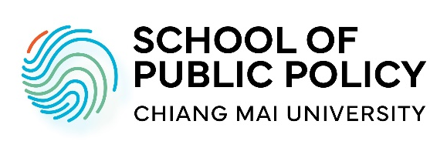
Doctoral Program
Application Checklist
School of Public Policy, Chiang Mai University
Name/ Last Name:
Gender:
Nationality:
Date of birth:
*** Please assemble all required application documents in the following order into one PDF file, and email to spp@cmu.ac.th, also upload your application from to CMU Admission portal at website: Application for Graduate study, Chiang Mai University (cmu.ac.th). The PDF file should be named as such:
"CMU-SPP_MA-Name Last name"…
☐ Application endorsed by potential advisor or approved by SPP Curriculum Committee.
☐ Application checklist (this sheet)
☐ Letter of Intent/Motivation letter
☐ CMU-SPP Doctoral Program Application Form
☐ Curriculum vitae
☐ Research Proposal
☐ Master thesis abstract
Academic certificates
☐ Master’s degree and transcript
Final grade(s):
☐ Bachelor’s degree and transcript. Final grade(s):
☐ One copy of English proficiency certification i.e. TOEFL (523 points paper-based; 193 computer-based; 69 iBT) or IELTS (score 5.5) and CMU-eTEGS (score 65).
☐ Recommendation letters from two referees (emailed by referees)
☐ One photocopy of Thai National ID or Passport

PERSONAL DETAILS
First/Given Name:
Middle Name (if any):

Last/Family Name:
Date of Birth (dd/mm/yyyy):
Country of Birth:
Citizenship:
Country of Permanent Residence:

EMERGENCY CONTACT

First/Given Name:
Last/Family Name:
Phone:
Email Address:

CONTACT DETAILS

Please provide the address of your permanent residence. If your correspondence/ mailing address is different from the permanent address during the period of the admissions process, please provide your correspondence address as well.
Address Line 1:
Address Line 2:
County/State/Province:
Postcode: Country:
Phone:
Email Address:
ACADEMIC QUALIFICATION
Please provide details and attach the degree certificate/diploma as well as transcript of the relevant previous degree(s) you obtained, starting with the most recent one.
* Applicants to doctoral program must upload both bachelor's and master's level records.

Qualifications 1
Institution / School / College:
City / Country:
Select Qualification: Bachelor’s Master’s Doctoral
Subject:
Thesis Title (if applicable):
Start Date:
(Expected) End Date:
(Expected) Graduation Date:
Official Duration (Years):

Qualifications 2
Institution / School / College:
City / Country:
Select Qualification: Bachelor’s Master’s Doctoral
Subject:
Thesis Title (if applicable):
Start Date:
End Date:
Graduation Date:
Official Duration (Years):

Qualifications 3
Institution / School / College:
City / Country:
Select Qualification: Bachelor’s Master’s Doctoral
Subject:
Thesis Title (if applicable):
Start Date:
End Date:
Graduation Date:
Official Duration (Years):

English Language Qualifications
Is English your first language?
Yes No
If “Yes”, applicants from countries classified by the UK government as majority native English-speaking may be exempt from submitting an English language qualification.
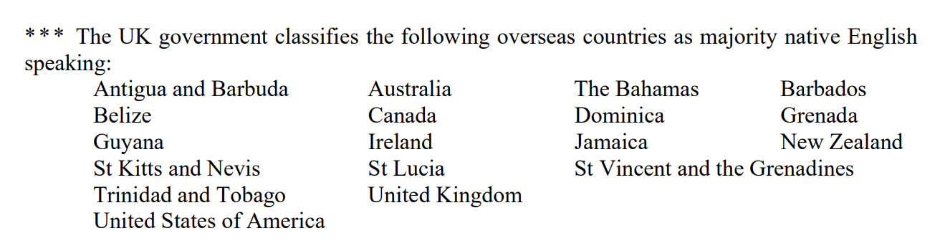
English Qualification:
(Required if English is not your first language or if exemption does not apply)
TOEFL (internet-based)
TOEFL (computer-based)
TOEFL (paper-based)
IELTS
CMU e-TEGS
Score:
Result Issue Date:

PROFESSIONAL EXPERIENCE
Please attach a copy of your CV/resume (including publication list if applicable)
Experience: 1
In this section you may list current and/or previous employments, internships, volunteer positions relevant to your application.
Employer/ Organization Name:
Location of work is based in:
Job Title:
Job Description:
Start Date:
End Date (if applicable):

Experience: 2
Employer/ Organization Name:
Location of work is based in:
Job Title:
Job Description:
Start Date:
End Date (if applicable):

Experience: 3
Employer/ Organization Name:
Location of work is based in:
Job Title:
Job Description:
Start Date:
End Date (if applicable):

POTENTIAL ADVISOR
Name:
Faculty:
Email:
REFEREES
Please provide details of your reference(s).
Referee 1
Title:
First/Given Name:
Last/Family Name:
Position:
Institution / Company:
Email Address:
Country:
Telephone number:

Referee 2
Title:
First/Given Name:
Last/Family Name:
Position:
Institution / Company:
Email Address:
Country:
Telephone number:

SOURCE OF FUNDING
Self-funded
CMU Presidential Scholarship (Optional)
Applicants must meet the following minimum requirements:
• Minimum GPA: 3.50 on a 4.00 scale (Master’s degree level)
• Certificate of English Language Proficiency (one of the following):
– IELTS: 6.0 or above
– TOEFL: 550 (paper-based), 183 (computer-based), or 79 (internet-based)
– CMU e-TEGS: 70 or above
*** Meeting the minimum requirements does not guarantee the award of the scholarship.
SUBMISSION
How did you hear about Chiang Mai University School of Public Policy?
What do you find most attractive about SPP Program or Chiang Mai University?

